**Running virtual machine on virtual box**

1. **Provide iso path to virtual machine**

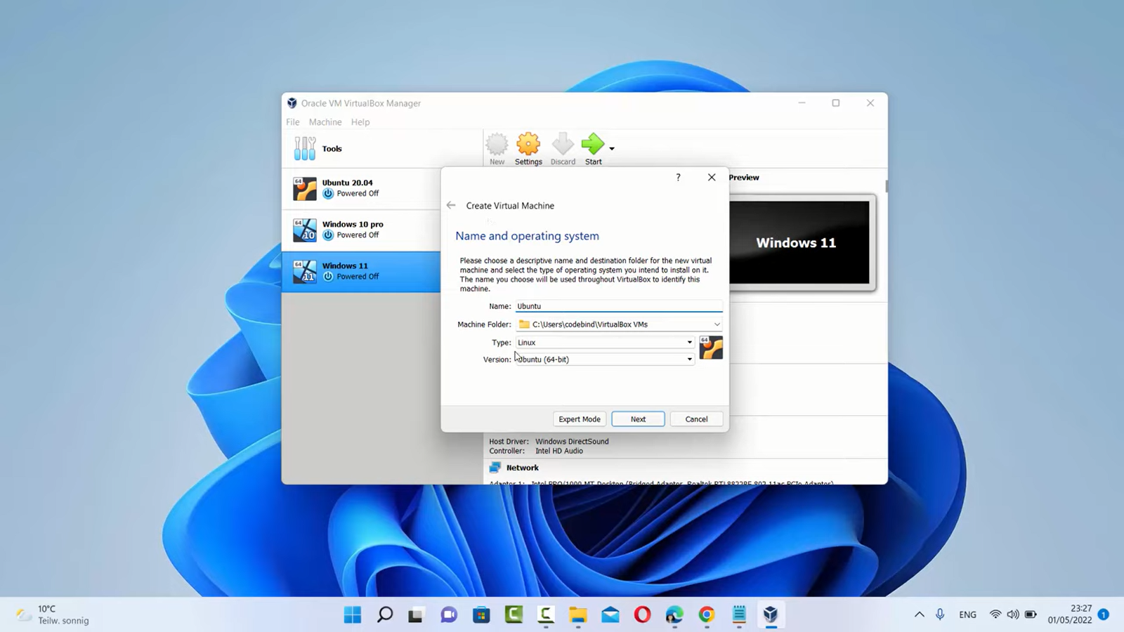

1. **Assign memory size to VM**

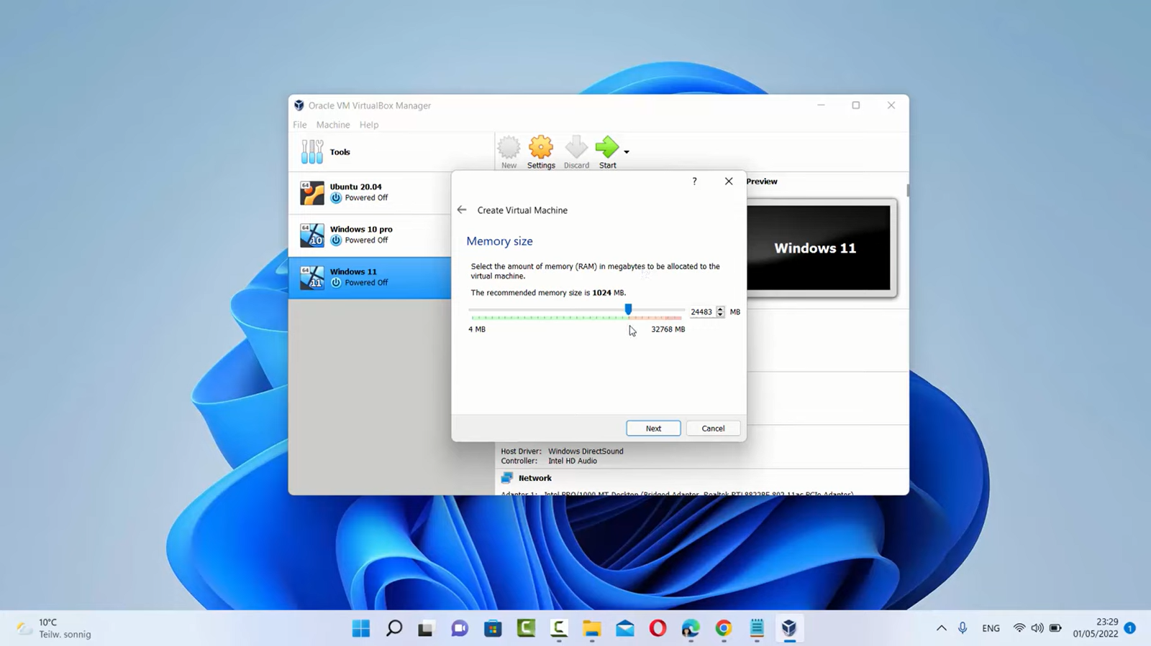

1. **Allocate Cpu cores to virtual machine**

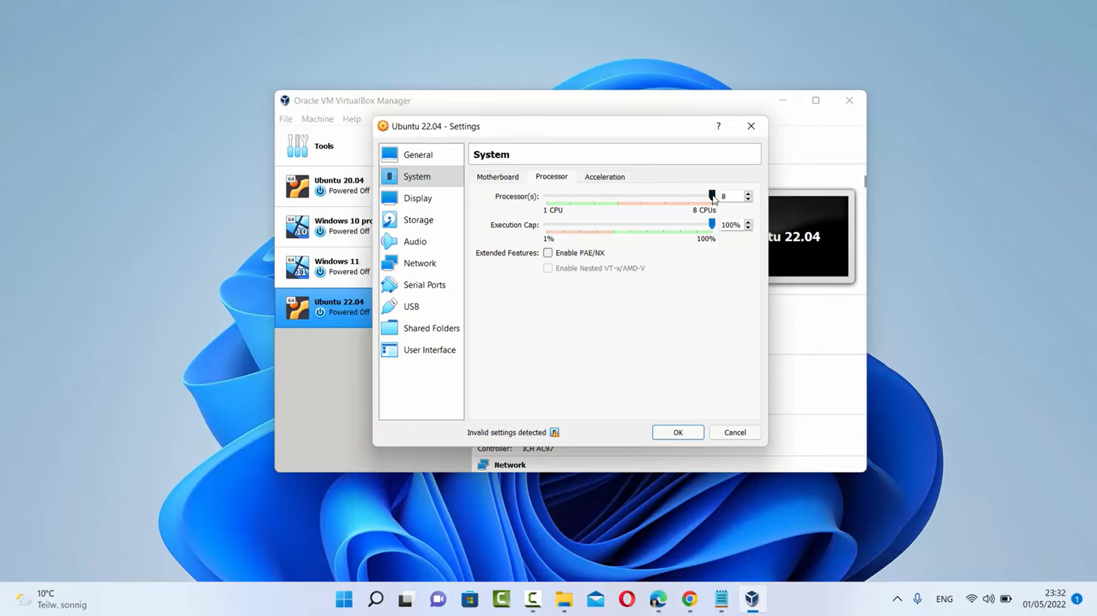

1. **Allocate appropriate disk size to the OS**

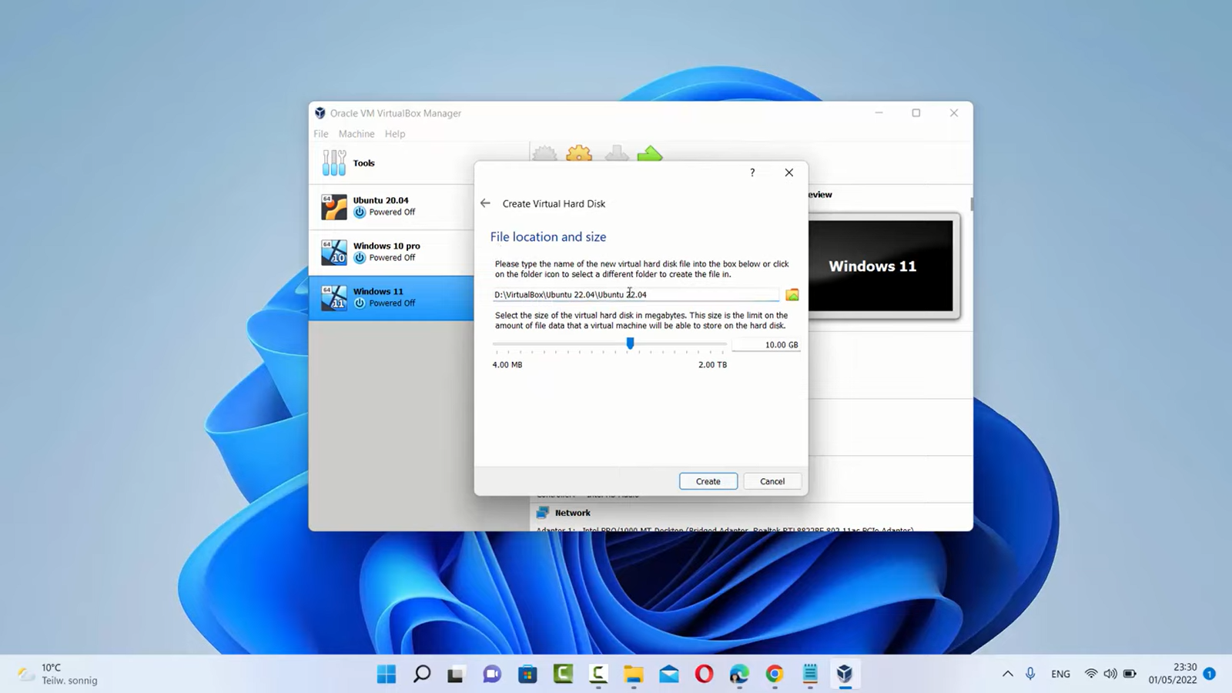

1. **Launch OS from the virtual machine menu**

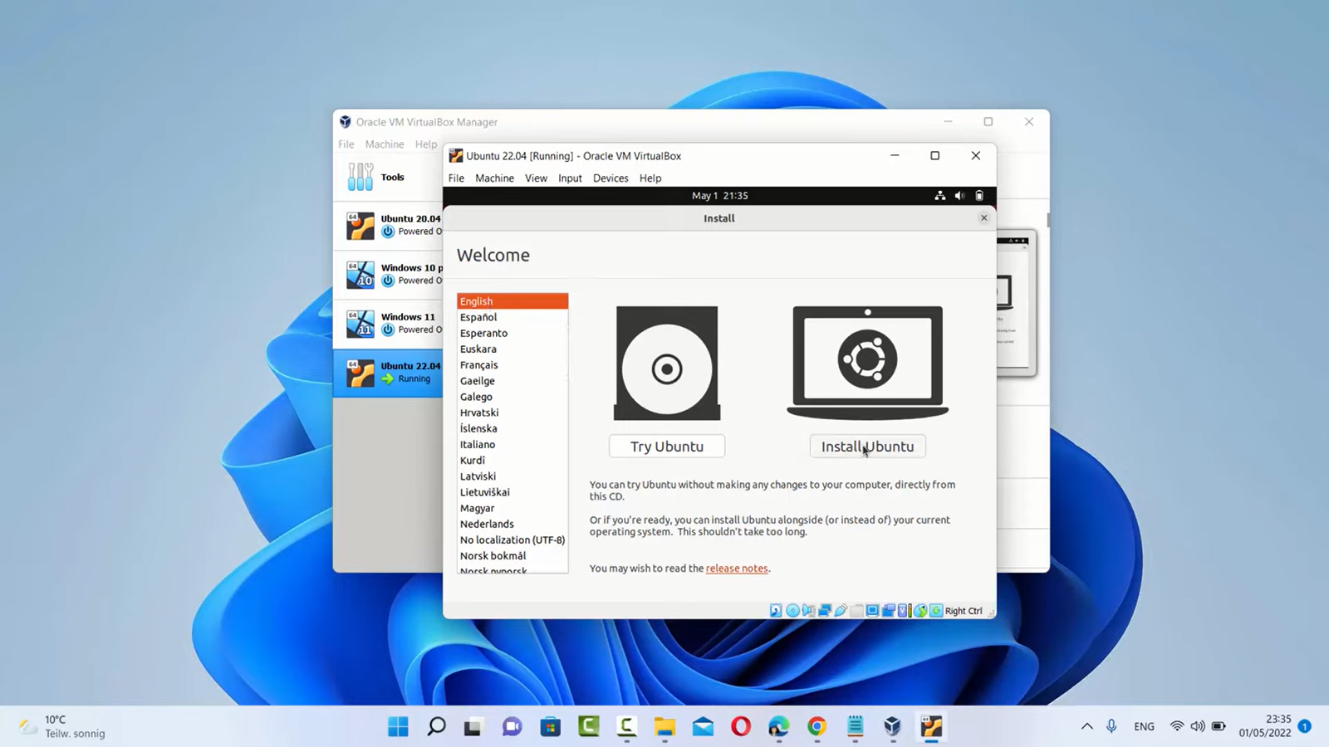

1. **Install the OS for the first time**

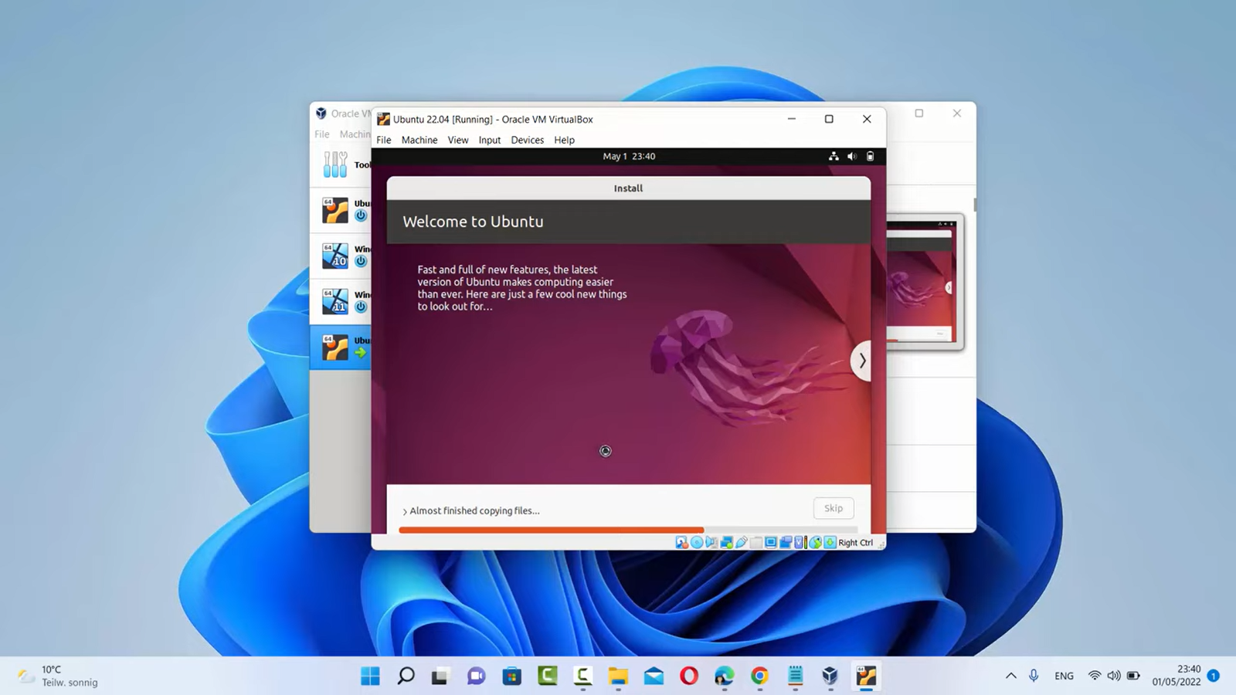

**Running virtual machine on KVM**

1. **Check whether CPU has hardware virtualization support.**

KVM only works if your CPU has hardware virtualization support

#sudo grep -c "svm\|vmx" /proc/cpuinfo

root@ubuntu:/home/tsec# sudo grep -c "svm\|vmx" /proc/cpuinfo

24

1. **Install KVM and dependent packages.**

#apt-get install qemu-kvm libvirt-clients libvirt-daemon-system bridge-utils

root@ubuntu:/home/tsec# apt-get install qemu-kvm libvirt-clients libvirt-daemon-system bridge-utils

1. **Check whether everything is working correctly.**

Run following command after logging back in as tsec and you should see an empty list of virtual machines.

This indicates that everything is working correctly.

root@ubuntu:/home/tsec# virsh -c qemu:///system list

   Id      Name                     state

-----------------------------------------------------

root@ubuntu:/home/tsec#

1. **Open Virtual Machine Manager application and Create Virtual Machine.**

root@ubuntu:/home/tsec# virt-manager

1. **Create and run Virtual Machines.**

